**VELAMMAL BODHI CAMPUS**

**(A SENIOR SECONDARY CBSE SCHOOL) 2023-2024**

**GRAND TEST – 3**

**GRADE: X – BATCH – 1 Time: 3 hours**

**SUBJECT: MATHS Maximum Marks: 80**

**General Instructions:**

**1. This Question Paper has 5 Sections A-E.**

**2. Section A has 20 MCQs carrying 1 mark each**

**3. Section B has 5 questions carrying 02 marks each.**

**4. Section C has 6 questions carrying 03 marks each.**

**5. Section D has 4 questions carrying 05 marks each.**

**6. Section E has 3 case based integrated units of assessment (04 marks each) with sub-parts.**

**7. Draw neat figures wherever required. Take π = 22/7 wherever required if not stated.**

**Section-A**

I. CHOOSE THE CORRECT ANSWER 20 x 1 = 20

1. If two positive integers a and b are expressible in the form a = pq2 and b = p2q ; p, q being

prime numbers, then LCM (a, b) is  
(a) pq (b) p3q3 (c) p3q2 (d) p2q2

2. If HCF (26, 169) = 13, then LCM (26, 169) =  
(a) 26 (b) 52 (c) 338 (d) 13

3. If α and β are the zeros of the polynomial f(x) = x2 + x + 1, then  + =  
(a) 1 (b) -1 (c) 0 (d) None of these

4. The value of k for which the system of equations 2x + 3y = 5, 4x + ky = 10 has infinite number of solutions, is  
(a) 1 (b) 3 (c) 6 (d) 0

5. If the system of equations: 2x + 3y = 7, (a + b) x + (2a – b) y = 21 has infinitely many solutions, then  
(a) a = 1, b = 5 (b) a = 5, b = 1 (c) a = -1, b = 5 (d) a = 5, b = -1

6. If ax2 + bx + c = 0 has equal roots, then c =

(a) (b) (c) (d)   
7. If the equation ax2 + 2x + a = 0 has two distinct roots, if

(a) a = ±1 (b) a = 0 (c) a = 0, 1 (d) a = -1, 0  
8. The sum of n terms of an A.P. be 3n2 + n and its common difference is 6, then its first term is

(a) 2 (b) 3 (c) 1 (d) 4  
9. If x is a positive integer such that the distance between points P (x, 2) and Q (3, -6) is 10 units, then x =

(a) 3 (b) -3 (c) 9 (d) -9  
10. If the distance between the points (4, p) and (1, 0) is 5, then p =

(a) ±4 (b) 4 (c) -4 (d) 0  
11. If triangles ABC and DEF are similar and AB=4 cm, DE=6 cm, EF=9 cm and FD=12 cm, the

perimeter of triangle ABC is:

(a) 22 cm (b) 20 cm (c) 21 cm (d) 18 cm

12. If ABC and DEF are two triangles and AB/DE=BC/FD, then the two triangles are similar if

(a) ∠A=∠F (b) ∠B=∠D (c) ∠A=∠D (d) ∠B=∠E

13. A tangent PQ at a point P of a circle of radius 5 cm meets a line through the centre O at a point Q such that OQ = 12 cm. Length PQ is  
(a) 12 cm (b) 13 cm (c) 8.5 cm (d) √119 cm

14. From a point Q, the length of the tangent to a circle is 24 cm and the distance of Q from the centre is 25 cm. The radius of the circle is

(a) 7 cm (b) 12 cm (c) 15 cm (d) 24.5 cm

15. If tan245° – cos2 30° = x sin 45° cos 45°, then x =

(a) 2 (b) -2 (c) (d)

16. The angle of elevation of the top of a tower from a point on the ground, which is 30 m away from the foot of the tower is 30°.Find the height of the tower.

(a) 10√3 m (b) 20√3 m (c) 30√3 m (d) √3 m

17. A circular park has a path of uniform width around it. The difference between the outer and inner circumferences of the circular path is 132 m. Its width is  
(a) 20 m (b) 21 m (c) 22 m (d) 24 m

18. A chord of a circle of radius 10 cm subtends a right angle at its centre. The length of the chord (in cm) is

(a) 5√2 (b) 10√2 (c) $\frac{5}{\sqrt{3}}$ (d) 10√3

**Question no: 19 & 20:**

(a)Both assertion (A) and reason (R) are true and reason (R) is the correct explanation of assertion (A)

(b)Both assertion (A) and reason (R) are true but reason (R) is not the correct explanation of assertion (A)

(c)Assertion (A) is true but reason (R) is false

(d)Assertion (A) is false but reason (R) is true

19. Assertion: If Sn is the sum of the first n terms of an A.P., then its nth term an is given by an=Sn–Sn–1.

Reason: The 10th term of the A.P. 5, 8, 11, 14, ................... is 35.

20. Assertion: . A bag has 3 red balls and 5 green balls. If we take a ball from the bag, then probability of getting red balls only 3/8.

Reason: Probability of getting red balls = number of red balls/total number of balls.

**Section-B**

II ANSWER THE FOLLOWING 5 x 2 = 10

21. Solve : 2x + 3y = 9 & 3x + 4y = 5

22. If sin(A + B) = 1 and cos (A – B) = √3/2, 0°< A + B ≤ 90°, A > B then find A and B

23. Find the smallest natural number by which 1200 should be multiplied so that the square root of the product is a rational number.

24. In Figure, PQ is a chord of length 8 cm of a circle of radius 5 cm and centre O. The tangents at P and Q intersect at point T. Find the length of TP.

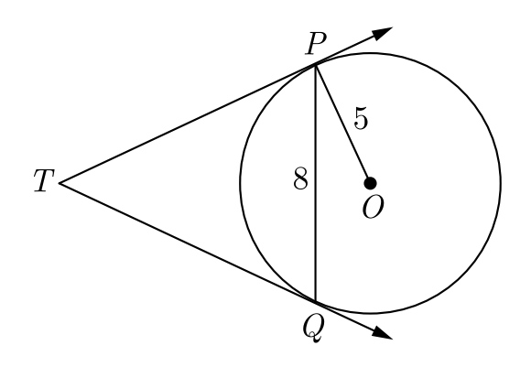

(OR)

Prove that tangents of a circle is perpendicular to the radius through the point of contact.

25.   If the zeros of the polynomial f(x) = 2x3 – 15x2 + 37x – 30 are in A.P., find them.

**Section-C**

III ANSWER THE FOLLOWING 6 x 3 = 18

26. Prove that √5 is irrational and also prove that 6-2√5 is irrational.

27. Find the zeros of the quadratic polynomial f(x) = abx2 + (b2 -ac) x -bc, and verify the Relationship between the zeros and it is coefficient

28. If -4 is a root of the quadratic equation x2+ px – 4 =0 and the quadratic equation x2 +px + k = 0 has equal roots, find the value of k. (OR)

From the top of a cliff 50 m high, the angles of depression of the top and bottom of a tower are observed to be 30° and 45° respectively. Find the height of the tower.

29. Prove that (cosec A – sin A) (sec A – cos A) = 1/(tan A + cot A)

30. Prove that the parallelogram circumscribing a circle is a rhombus.

(OR)

Prove that the opposite sides of a quadrilateral circumscribing a circle subtends Supplementary angles at the centre of the circle.

31. 17 cards numbered 1, 2, 3, ---, 17 are put in a box and mixed thoroughly. One person draws a card from the box. Find the probability that the number number on the card is:

(i) odd (ii) a prime (iii) divisible by 3 and 2 both

**Section-D**

IV ANSWER THE FOLLOWING 4 x 5 = 20

32. A motor boat whose speed is 18 km/h in still water takes 1 hour more to go 24 km upstream than to return downstream to the same spot. Find the speed of the stream.

(OR)

A train travels 180 km at a uniform speed. If the speed had been 9 km/h more, if would have taken 1 hour less for same journey. Find the speed of the train.

33. (a) State and Prove Basic Proportionality Theorem.

(b) In Figure, two triangles ABC and DBC lie on the same side of base BC. P is a point on BC such that PQ ∥ BA and PR ∥BD. Prove that QR ∥ AD.

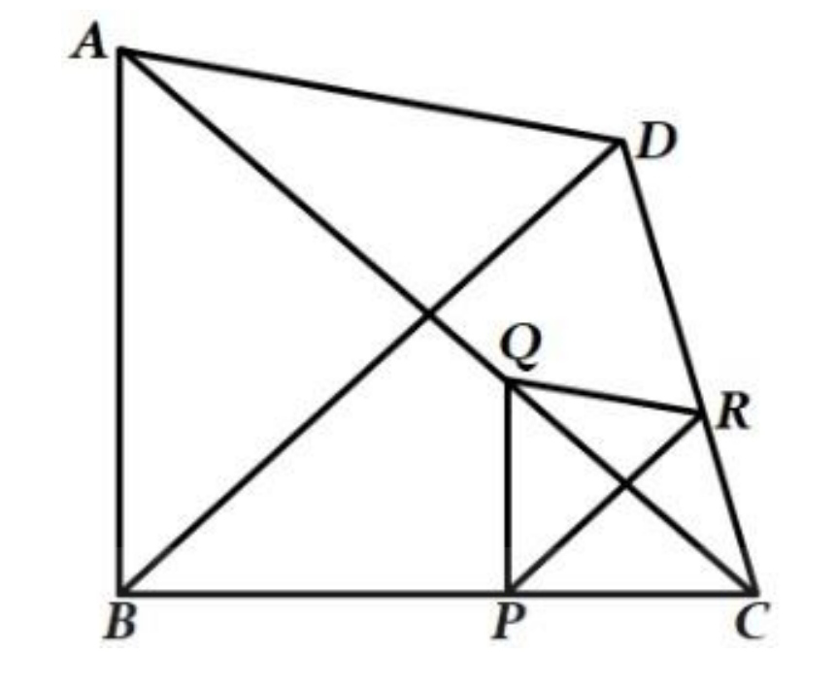

34. A tent is in the shape of a cylinder surmounted by a conical top. If the height and diameter of the cylindrical part are 2.1 m and 4 m respectively, and the slant height of the top is 2.8 m, find the area of the canvas used for making the tent. Also, find the cost of the canvas of the tent at the rate of Rs 500 per m2.

(OR)

A solid is in the form of a cylinder with hemispherical ends. The total height of the solid is 19 cm and the diameter of the cylinder is 7 cm. Find the volume and total surface area of the solid.

35. The mean of the following frequency table is 50 and total frequency is 120. Find the missing frequencies x and y.

|  |  |  |  |  |  |
| --- | --- | --- | --- | --- | --- |
| Class | 0-20 | 20-40 | 40-60 | 60-80 | 80-100 |
| frequency | 17 | x | 32 | y | 19 |

**Section-E**

IV ANSWER THE FOLLOWING 3 x 4 =12

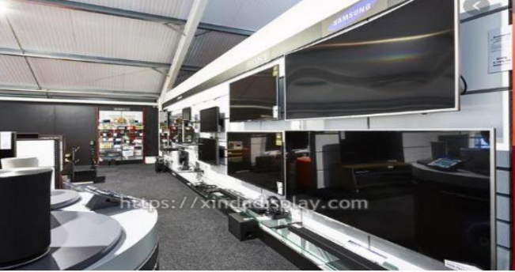36. India is competitive manufacturing location due to the low cost of manpower and strong technical and engineering capabilities contributing to higher quality production runs. The production of TV sets in a factory increases uniformly by a fixed number every year. It produced 16000 sets in 6th year and 22600 in 9th year.

a) Find the production during 8th year.

b) Find the production during first 3 years.

c) In which year, the production is Rs 29,200.

OR

Find the difference of the production during 7th year and 4th year.

37. Satellite Images : Satellite images are images of Earth collected by imaging satellites operated by governments and businesses around the world. Satellite imaging companies sell images by licensing them to governments and businesses such as Apple Maps and Google Maps. It should not be confused for astronomy images collected by space telescope. Barun lives in Jaipur in Vaishali. Satellite image of his colony is shown in given figure. In this view, his house is pointed out by a flag, which is situated at the point of intersection of x and y - axes. If he goes2 cm east and 3 cm north from the house, then he reaches to a grocery store, If he goes 4 cm west and 6 cm south from the house, then he reaches to his office. If he goes 6 cm east and 8 cm south from the house, then he reaches to a food court. If he goes 6 cm west and 8 cm north from the house, he reaches to a his kid’s school.

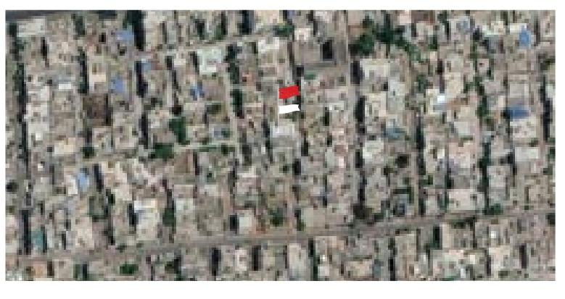

Based on the above information, answer the following questions.

(i) Find the distance between grocery store and food court.

(ii) Find the distance of the school from the house.

(iii) If the grocery store and office lie on a line, what is the ratio of distance of house from grocery store to that from office?

OR

Find the ratio of distances of house from school to food court.

38. Two poles, 30 feet and 50 feet tall, are 40 feet apart and perpendicular to the ground. The poles are supported by wires attached from the top of each pole to the bottom of the other, as in the figure. A coupling is placed at C where the two wires cross.

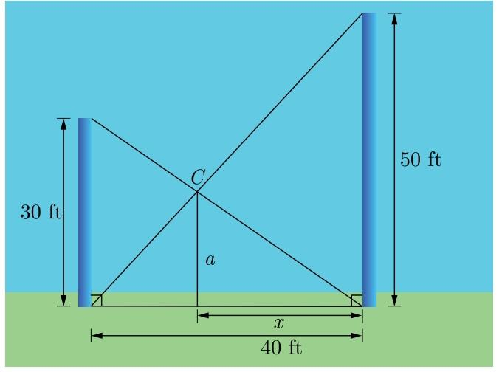

(i) What is the horizontal distance from C to the taller pole?

(ii) How high above the ground is the coupling?

(iii) How far down the wire from the smaller pole is the coupling?